**ECE2049 A-2022 Lab 4**

**Sign-off Sheet**

***Bonus Sign-off***: **None  *Report due***: **Wed 10/12**

**Student 1:** Cristobal Rincon Rogers

**Student 2:** Lili Loughlin

| Welcome screen with function generator instructions & button menu | 5 |  |
| --- | --- | --- |
| DC voltage controlled by Scroll Wheel with screenshot (s) | 10 |  |
| Tabulating range of DC voltages, etc with a screen shot(s) | 5 |  |
| Square wave (scroll wheel amplitude) with a screen shot(s) | 15 |  |
| Sawtooth wave (fixed amplitude) with screenshot(s) | 15 |  |
| Triangle wave (fixed amplitude) with screenshot(s) | 15 |  |
| ***BONUS: Implement triangle wave 100Hz to 1KHz (scroll wheel) with screen shot(s)*** | ***10*** |  |
| Testing ADC and DAC linearity including tabulation of at least 6 values | 10 |  |
| ***Report*** | 25 |  |
| ***Total points*** | 100  (110) |  |

# Table of Contents

**Table of Contents** **2**

**Introduction** **3**

**Questions / Discussion** **4**

**Conclusion** **5**

# Introduction

The purpose of this lab is to gain further experience with SPI by using the MSP430 and MCP4921 DAC to make a function generator. We will learn how to create and measure values from several functions, as well as test the accuracy of the DAC and the ADC12.

# Questions / Discussion

1. Do you have to repeatedly send the code to the DAC to maintain the voltage or do you only need to send the code once then give the LDAC?
   1. You only have to send the code to the DAC once and then give the LDAC once to maintain the voltage.

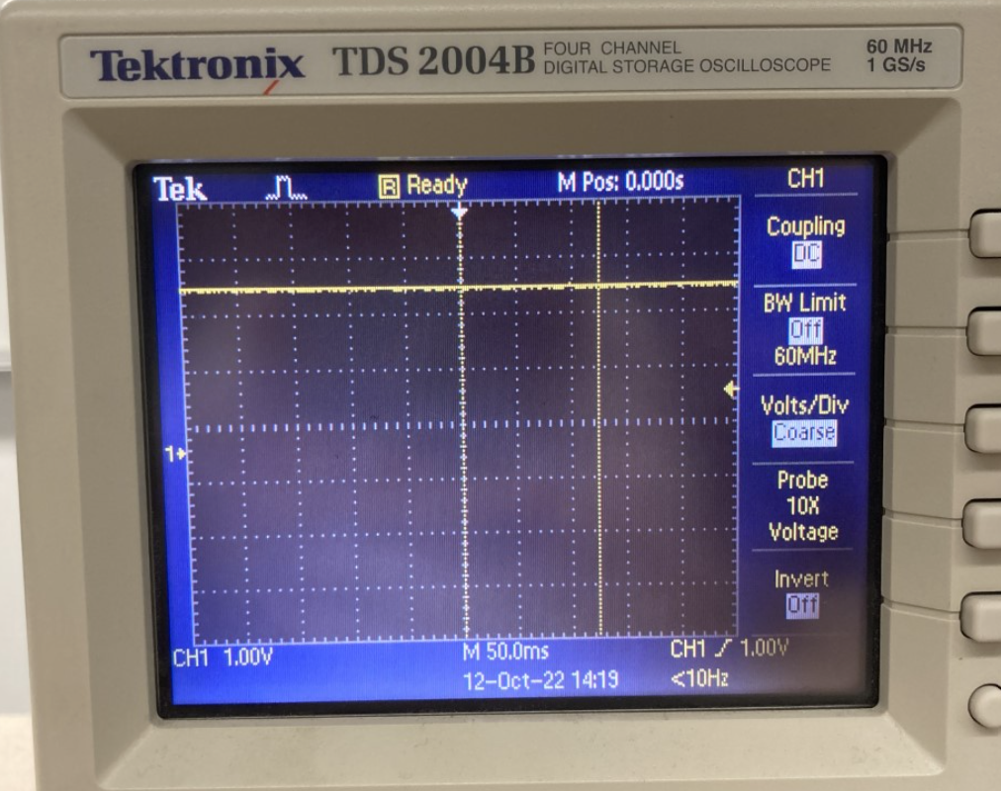

Figure 1: DC Output on the Oscilloscope

1. What are the minimum and maximum DC voltages the MCP4921 DAC can actually generate when P7 is in the 3.3V position? Is it truly a “rail-to-rail” DAC?
   1. The minimum and maximum DC voltages the MCP4921 DAC can actually generate when P7 is in the 3.3V position are 600mV and 3.36V, respectively.
2. Measure the minimum and maximum DC voltages your DAC can actually generate when P7 is in the 5V position. Are there any offsets at either supply voltage setting?
   1. The minimum and maximum DC voltages the MCP4921 DAC can actually generate when P7 is in the 5V position are 614mV and 5.22V, respectively.
3. Take a screenshot of your square wave output on the oscilloscope showing the period.
   1. The period, as shown, is 124 ms.

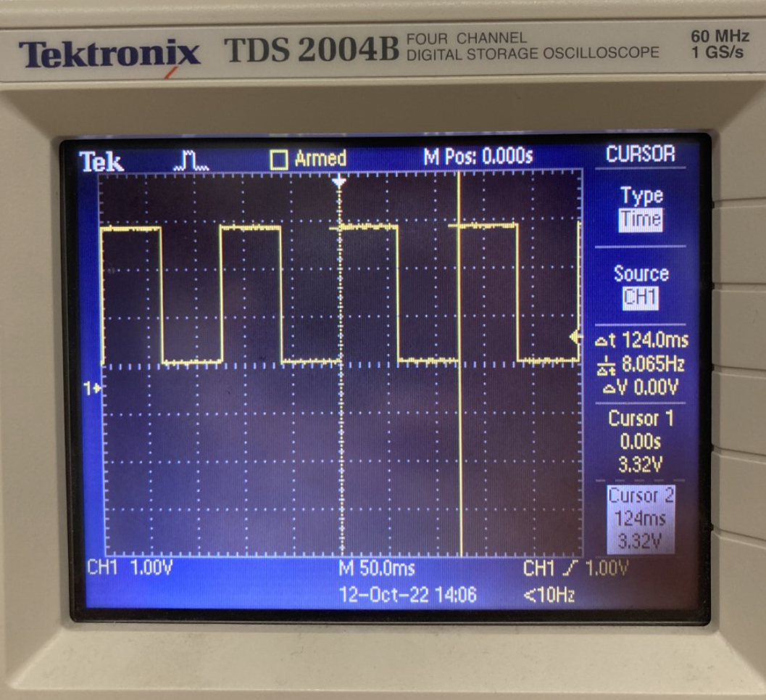

Figure 2: Square Wave on the Oscilloscope

1. What is the function of LDAC? How soon is the output voltage available after LDAC is applied? How fast can you effectively change the output voltage?
   1. The LDAC controls the output of the DAC output voltage. LDAC is active low, meaning that by default the LDAC is HIGH and when set LOW, the output voltage goes out. The theoretical fastest that the LDAC can be changed is 4.5 microseconds.
2. (Sawtooth) What are your step size increments and step duration? Why? You must justify your step size!! Just choosing a number is not enough.
   1. The calculated step size is 3.3V / 4095, where each delta time is 4.884E-6. Therefore, when using the SMCLK the theoretical max_count for register TA2CCR0 is 4. However, due to the limitations of the LDAC, the smallest possible max_count we could use was 35. This result yielded the best output without overlap and much noise in waves.
3. Take a screenshot of your sawtooth wave output on the oscilloscope showing the period. Take a zoomed in screen shot, too, showing your staircase approximation.
   1. The period, as shown, is 140.4 ms.

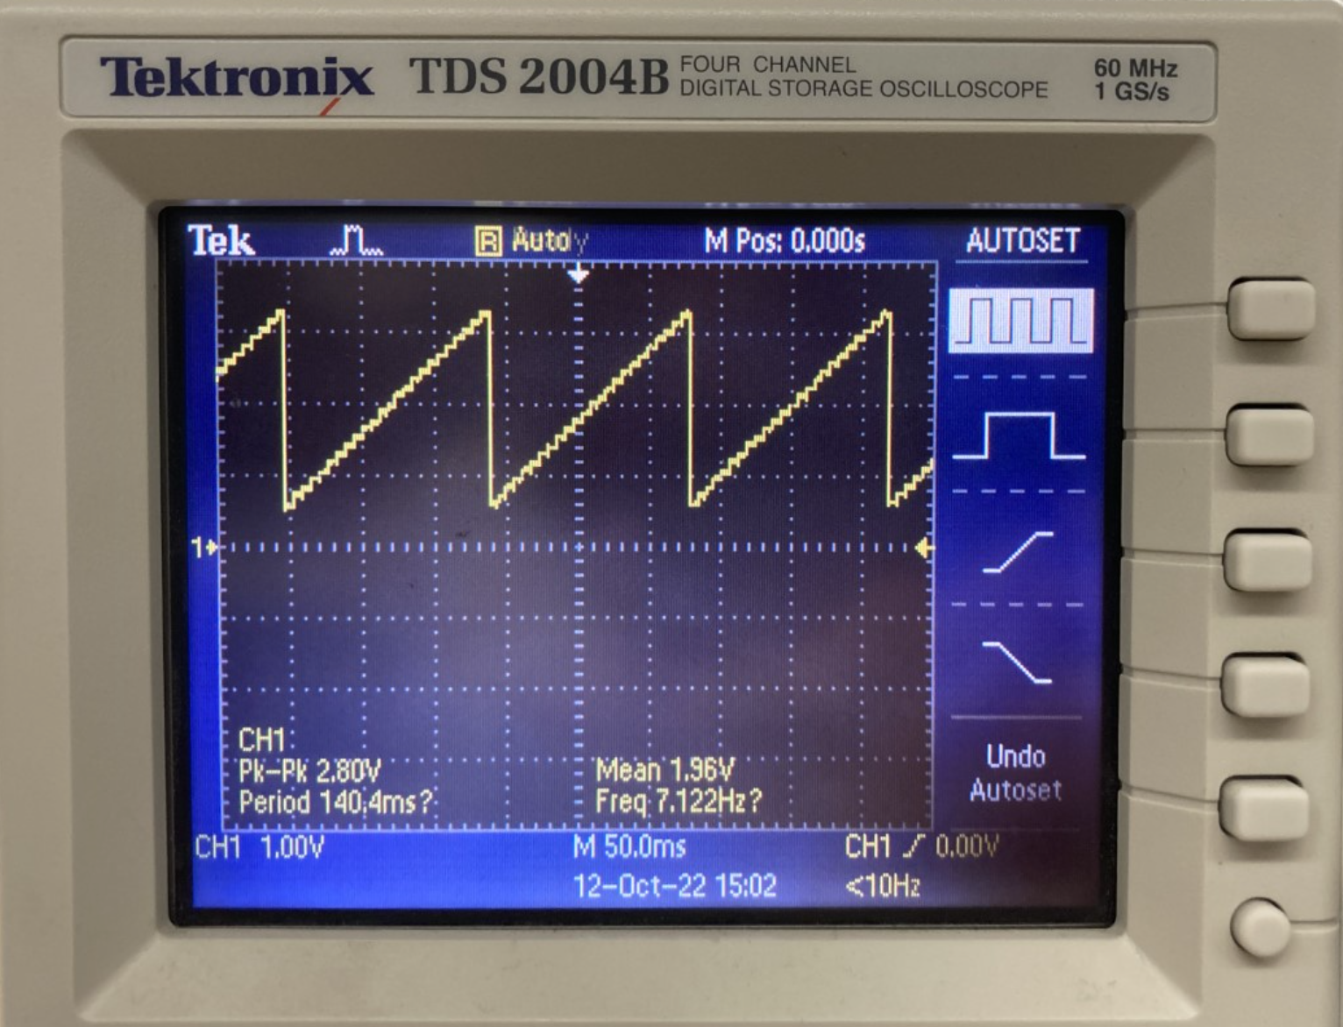

Figure 3: Sawtooth Wave Output

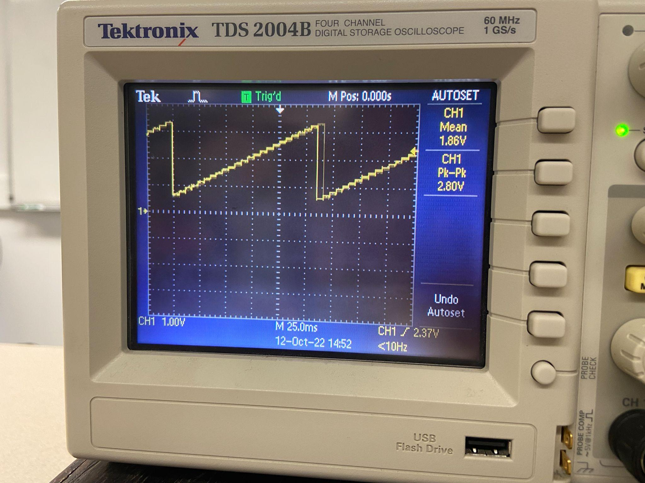

Figure 4: Sawtooth Staircase Approximation

1. (Triangle) What are your step size increments and step duration? Why? Again you must justify your choices.
   1. The step size was the same as the sawtooth wave. We simply subtracted from our max value of VCCADC to get the other side of the sawtooth to get the triangular wave. The calculated step size is 3.3V / 4095, where each delta time is 4.884E-6. Therefore, when using the SMCLK the theoretical max_count for register TA2CCR0 is 4. However, due to the limitations of the LDAC, the smallest possible max_count we could use was 45. This result yielded the best output without overlap and much noise in waves.
2. Take a screenshot of your triangle wave output on the oscilloscope. Take a zoomed in screen shot, too, showing your staircase approximation.

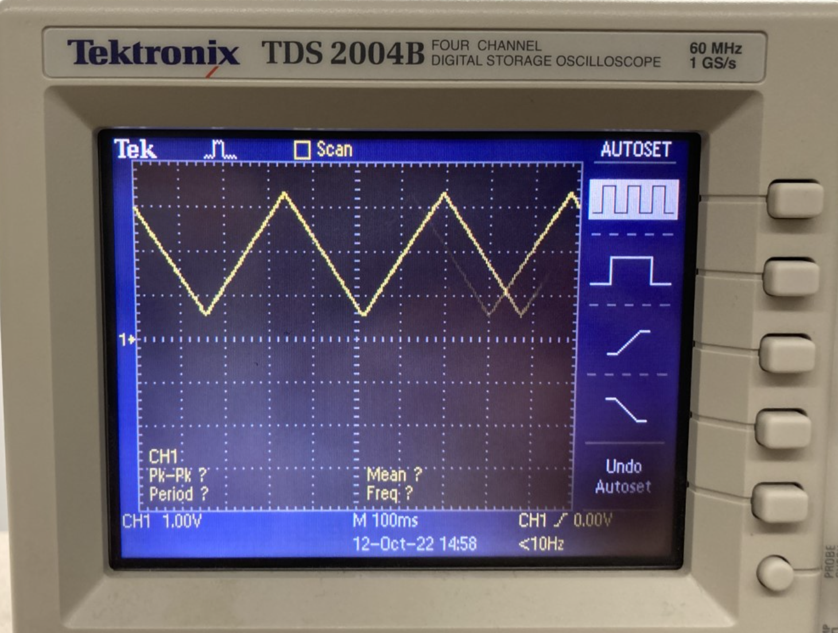

Figure 3: Triangle Wave Output

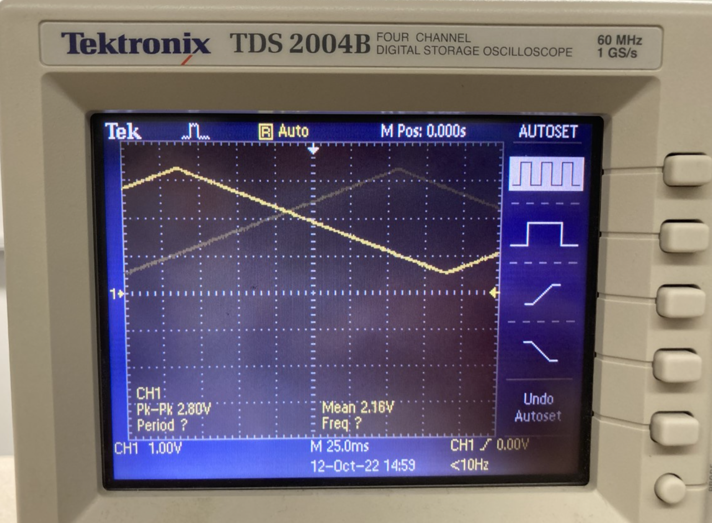

Figure 4: Triangle Staircase Approximation

# Conclusion

In this lab, we gained familiarity with SPI by creating a simple function generator with the MSP430 and the MCP4921 DAC. Not only were we able to generate specific functions on the oscilloscope such as a square wave, triangle wave, and sawtooth wave, we were also able to calculate specific values from said functions. Finally, we discussed and compared the accuracies of the DAC and the ADC12.